id: 08_1

Read More buttons are not present on the Home page

Reporter: [Liudmyla Kotenko](https://www.linkedin.com/in/liudmyla-kotenko-022499235/)  
Assignee: [Cillian Murphy](https://en.wikipedia.org/wiki/Cillian_Murphy) (developer who responds for the home page)

Description:

There are no "Read More" buttons present on the Home page of <https://practice.automationtesting.in/> web application

Steps to reproduce:

1) Open the browser

2) Enter the URL “http://practice.automationtesting.in/”

3) View that the "Read More" button is not displayed under the "Add to Basket" buttons

Actual result:

"Read More" buttons are not present on the Home page

Expected result:

"Read More" buttons are present on the Home page and are clickable

Priority: (left this for Product Owner)  
  
  
Severity:

S3

Build version:

24.02.2

Environment:  
[UAT3](https://practice.automationtesting.in/)

Operation System and Browser:

MacOS Ventura 13.1  
Google Chrome Version 122.0.6261.57 (Official Build) (arm64)

Attachments:

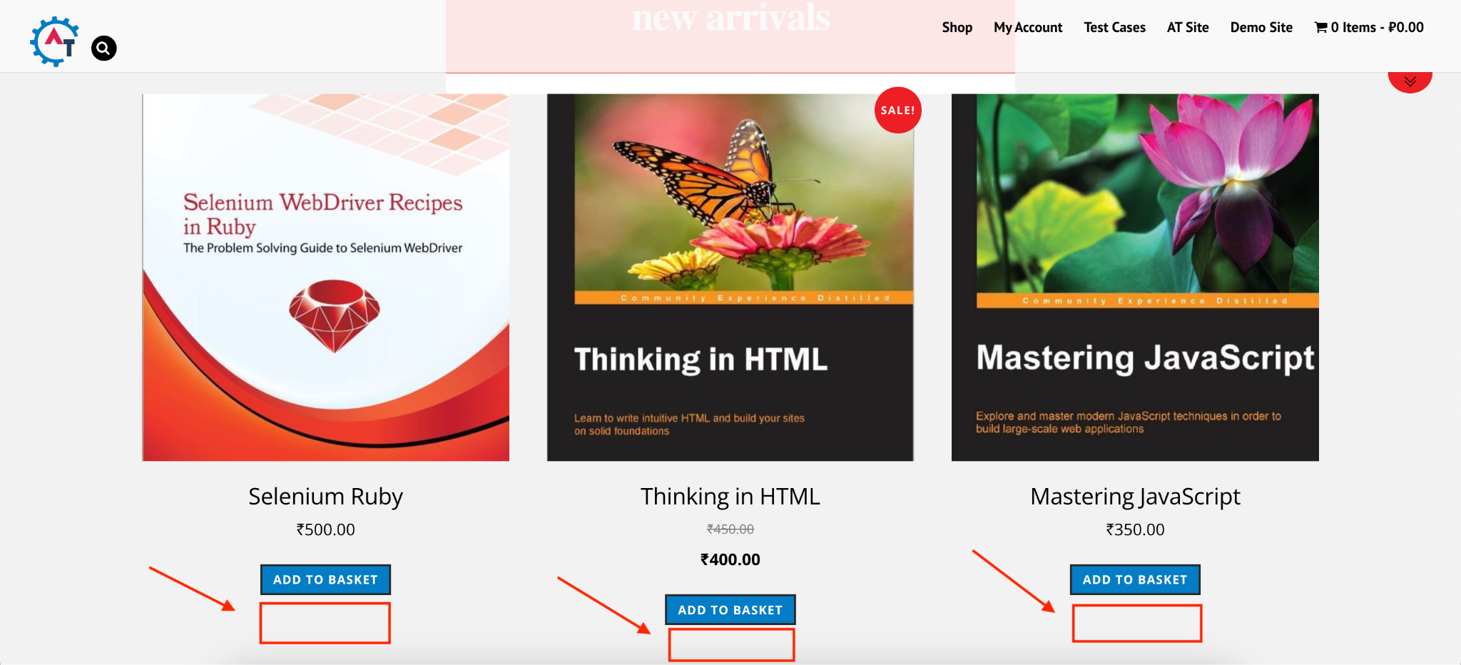

Linked User Story:

<https://practice.automationtesting.in/test-cases/>

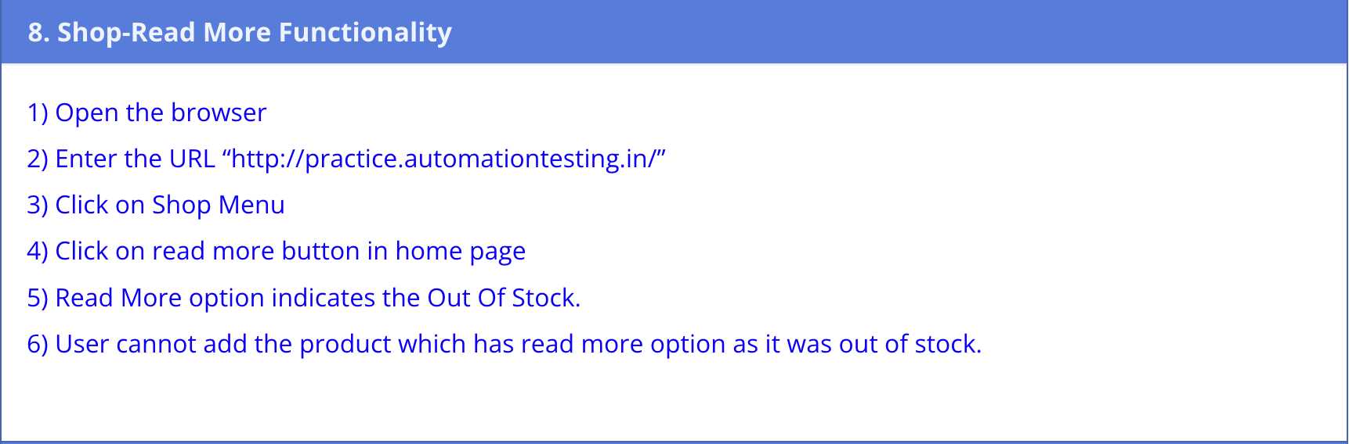

Notes for the developer's team:

"Read more" buttons are absent on all pages, I think after fixing this defect buttons will appear everywhere. I have checked feature toggles for this environment and the feature toggle for "Read More" buttons is checked, so maybe the problem is in code.

Build version 24.02.1 did not have this issue.

*Comments for viewers of my Test Automation Assessment:*  
  
  
Comments for id: 08_1

I spent a lot of time trying to find the "Read More" button on this website and unfortunately did not find it even with a special tool, so I decided to show how I handle such situation in real life. My preconditions were:

1. I am QA who runs the list of automated test cases after the new build was deployed (regular smoke testing for new builds).
2. My test case number Shop_08 failed (Iets imagine that it always worked before this)

So as a responsible QA, I have created a defect report with unique id: 08_1(for better orientation to which test case it relates) and with the summary: Read More buttons are not present on the Home page (I have not written a name of this field for more realistic view of my defect report).

About the section Linked User Story, I understand that the attached photo is the test scenario for Shop_08, and the real user story should have a format:

*As [a user persona], I want [to perform this action] so that [I can accomplish this goal].”*

with all provided accepted criteria, but I decided to move forward with covering other test scenarios.